**Exercise 2: Implementing the Factory Method Pattern**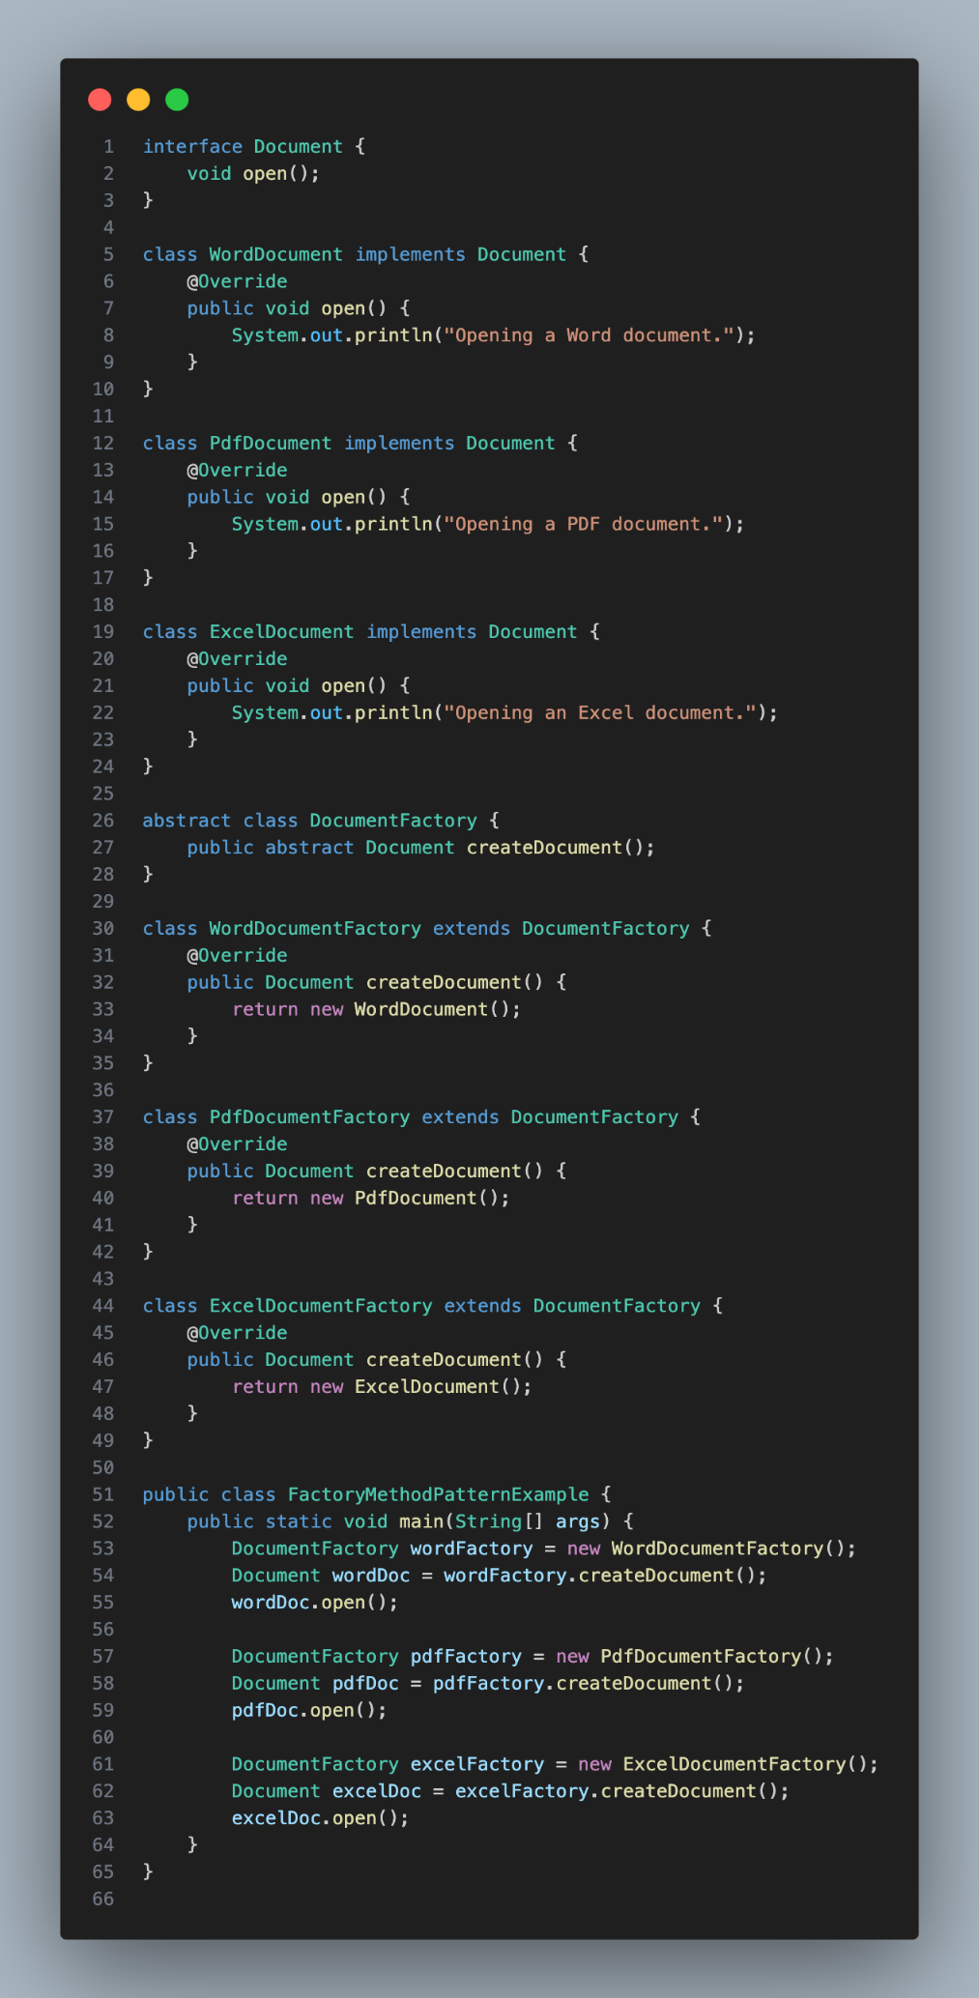

**Output**

